**Phase 1 🡪 Creating the Report**

Create a report with the name as **My_Sales_Report** based on the Sales_Data file.

There are following visuals on the default Page 1 in that report:

**Cost by Color** ascolumn chart.

**Cost by Neck Style** as Pie Chart

**Cost by Pattern by Sleeve Length** as Matrix

**Cost by Line** as line chart

Note 🡪 In **Page Size** section of Report, under **Type** property select **Custom.** And then in **Height** type value as **1000**. This will increase the Report height. Place the visuals with good spacing between them. This will help later in pinning the visuals in the Dashboard.

Save all the changes done to the report locally first.

The report should get the following look:

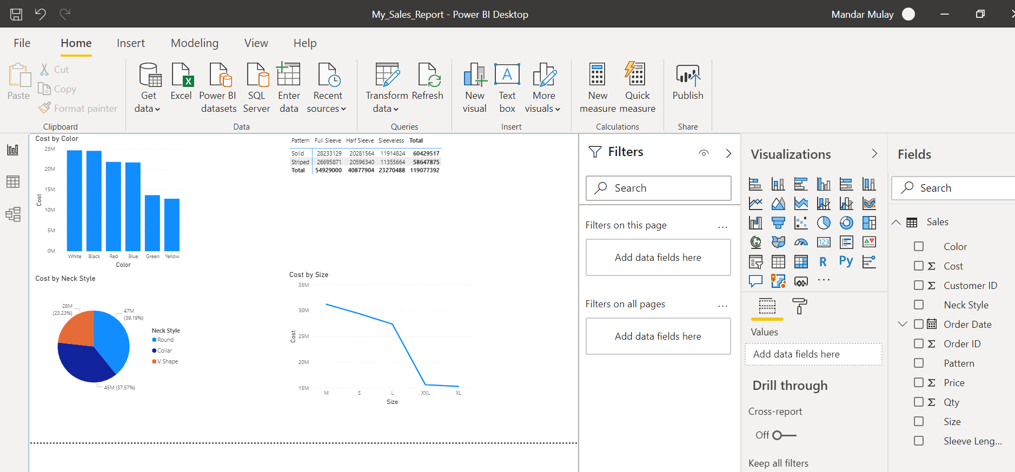

**Phase 2 🡪 Publishing the Report**

1. In Power BI Desktop, on the **Home** tab, click **Publish**.
2. **Sign in** window comes. Enter your Power BI user name and password if you had not signed initially. If you had signed in initially then **Sign in** window will not come.
3. Keep **My Workspace** as the Destination selected and simply click on the Select button.
4. The report will then be published to the Power BI portal. When the window displays Success, click on the hyperlink **Open 'My_Sales_Report.pbix' in Power BI** to view the report online.
5. When the browser opens, if you are prompted to enter your Power BI credentials, enter your email

address and password, and wait for the report to open. Also click on the **Got it** button.

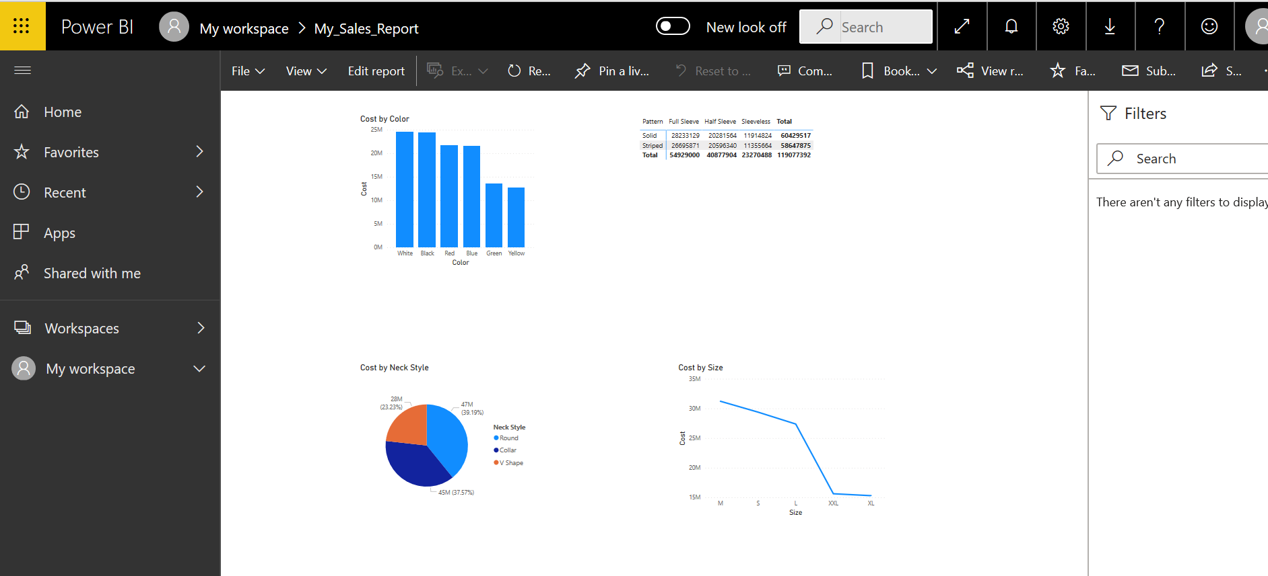

**Phase 3 🡪 Creating Dashboard from the Report**

1. On the **Cost by Color** column chart, click **Pin visual**.
2. In the **Pin to dashboard** dialog box, click **New dashboard**, type **My_Sales_Dashboard**, and then

click **Pin**. Ignore the Pinned to Dashboard window which pops up. It will disappear.

1. On the **Cost by Neck Style** pie chart, click **Pin visual**.
2. In the **Pin to dashboard** dialog box, click **Existing dashboard**, in the list click **My_Sales_Dashboard** and then click **Pin**. Ignore the Pinned to Dashboard.
3. In the left pane, expand **My Workspace**.
4. Under **Dashboards**, click **My_Sales_Dashboard**.

The Dashboard will have the following look:

